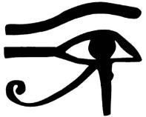mcaent2l[1]

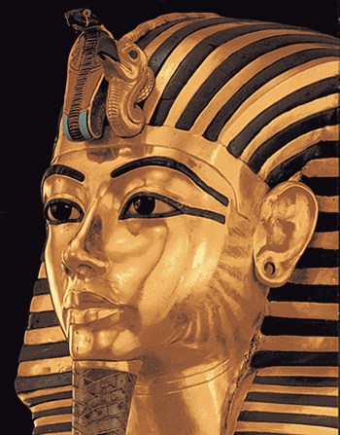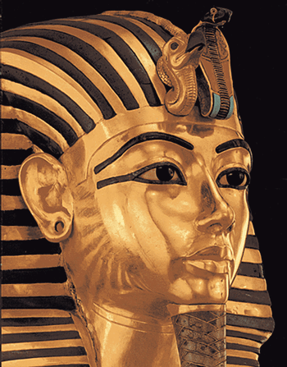

**++++LYNNWOOD LOCATION++++**

**St. Mary’s Coptic Orthodox Church**

**Presents the 25th Annual**

**Egyptian Bazaar & Dinner**

**Saturday, Oct 18th 2014**

## 12:00pm - 8:00pm

|  |  |  |  |
| --- | --- | --- | --- |
| **Taste of Egypt Sit-Down Dinner Menu:** | | | |
| **Appetizers** | **Main Course** | **Dessert** | **Beverages** |
| **Green Salad**  **Golden Lentil soup**  **Pita Bread** | **Stuffed Grape Leaves**  **Egyptian Kofta (Beef) Chicken**  **Queen of potatoes**  **Vegetables** | **Tasty Egyptian Dessert** | **Soft Drinks Water**  **Coffee**  **Tea** |

## Sit-Down Dinner: $15 (adults), $9 (kids)

## Priority seating for pre-purchased tickets

## Take your picture dressed like a Pharaoh

***Turkish coffee***

***Egyptian baked pastries***

***Delicious Egyptian desserts***

***Authentic Egyptian souvenirs***

***Coptic Christian books & gifts***

**LOCATION**  **Trinity Lutheran Church**

**6215 196th street south west Lynnwood, WA 98036-5917**

**DIRECTION : Trinity Church is west of "James Plaza"(Albertson's) in Lynnwood. James plaza is at 196th and Highway 99 Lynnwood.**

***For more information or to purchase tickets, please visit:*** [***www.stmaryseattle.com***](http://www.stmaryseattle.com)

***Or call (425)330-7719 or (425)443-9834 or (206)714-5094***